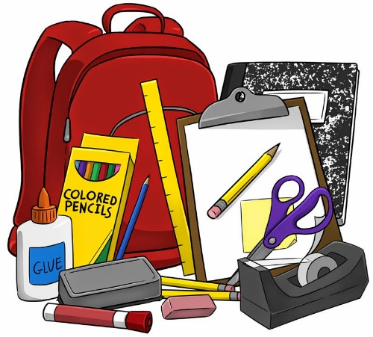
Groveland Elementary
6th Grade Supply List
2025-2026

- Headphones or earbuds (labeled or bagged with your name)
- 3 notebooks (no binders or trapper keepers)
- 6 two-pocket folders - 6 different colors or designs
- 8 black dry-erase markers and eraser or old sock
- 1 package of multi-colored highlighters
- Pencil case (box, basket, pouch, etc.)
- 12+ sharpened pencils
- 2 boxes of tissues
- 1 container of wipes
- 9 x 12 sketchbook for Art class

